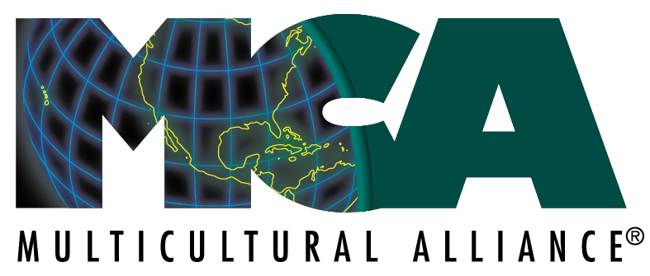

The Seventy-Third
Multicultural Alliance Gala

Thursday, February 29, 2024

We are a local organization whose mission is to promote inclusion, diversity and understanding while working toward eliminating bias, bigotry, and oppression in our community.
Funds raised from this annual event sustain and underwrite year-round local programming. Our programs include Interfaith Dialogues, Seminary Interfaith Retreat, Camp CommUNITY, MCA Table Talk, People’s Art Collaborative, presentations, and workshops.
Platinum Sponsor $10,000
Gold Sponsor $7,000
Silver Sponsor $5,000
Bronze Sponsor $3,000
Single ticket $300

Fort Worth Club
10 guests per sponsorship
6:30 - 8:30 PM

Food, Drinks, Raffle, Auction and Fun
Complimentary Valet Parking
(Please bring your parking ticket to for
validation at the Check-in table)
Reservations at Check-in

Attire: Business

$1000 of sponsorship and $100 of individual tickets are not tax deductible.

R.S.V.P.
I/We would like to be a sponsor
Please return to:
The Multicultural Alliance
500 West Seventh Street, Suite 1707, Unit 15
Fort Worth, Texas 76102
817.332.3271 ckimberling@mcatexas.com 817.332.3272 (fax)

Thank you and We look forward to seeing you on March 4, 2009.
Name on Card
Card Number
Expiration Date Visa MasterCard
3 digit Signature Panel Code/reverse side
Signature

Name

Organization

Address

City, State, Zip

Email Address

Phone Number
Please make your check payable to Multicultural Alliance
Our mailing address: MCA, PO Box 12569 Fort Worth, Texas 76110
For more info, contact us: 817-733-6562, ckimberling@mcatexas.com www.mcatexas.com

